[**https://raosh.notion.site/raosh/OSS-5b6ed4cd3b624304811533b2fe306082**](https://raosh.notion.site/raosh/OSS-5b6ed4cd3b624304811533b2fe306082) **(VCS = git, SVN, HG mercurial)**

[**https://docs.google.com/document/d/1z6jpvF3MaAcmzJs90wcFd3s4j6h7HckxiYxhguKg2nA/edit?usp=sharing**](https://docs.google.com/document/d/1z6jpvF3MaAcmzJs90wcFd3s4j6h7HckxiYxhguKg2nA/edit?usp=sharing) **(Mohit - ftp,nfs,bugzilla,debian,sonar)**

[**https://github.com/RiteshWanave/oss**](https://github.com/RiteshWanave/oss)

1. **Bugzilla**

[**https://bugzilla.readthedocs.io/en/latest/installing/quick-start.html**](https://bugzilla.readthedocs.io/en/latest/installing/quick-start.html)

1. **SVN**

[**https://meetawaiszafar.medium.com/install-configure-svn-server-on-ubuntu-20-04-with-apache2-6dcd7d9a49e9**](https://meetawaiszafar.medium.com/install-configure-svn-server-on-ubuntu-20-04-with-apache2-6dcd7d9a49e9)

**svnadmin create our_repo**

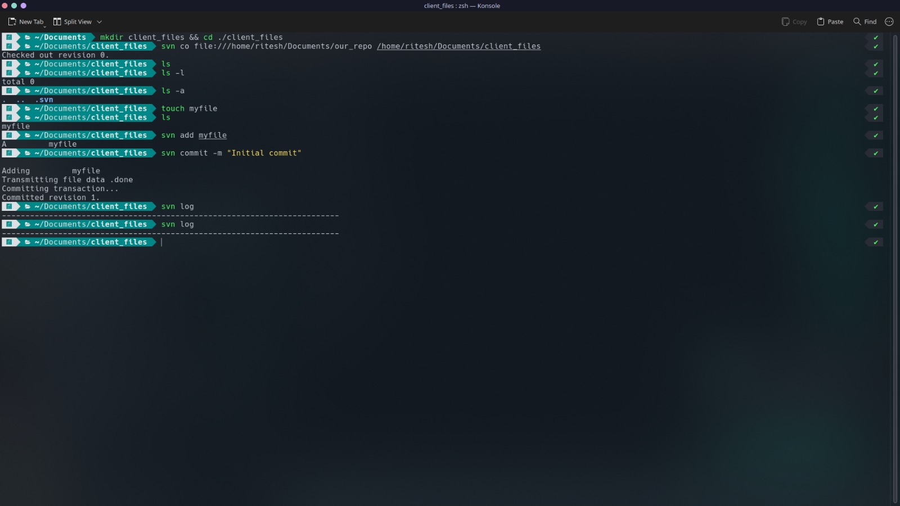

**svn log**

**svn log -r 0:HEAD**

1. **Joomla**

[**https://hostadvice.com/how-to/website-builders/joomla/how-to-install-joomla-on-an-ubuntu/**](https://hostadvice.com/how-to/website-builders/joomla/how-to-install-joomla-on-an-ubuntu/)

1. **DEBIAN**

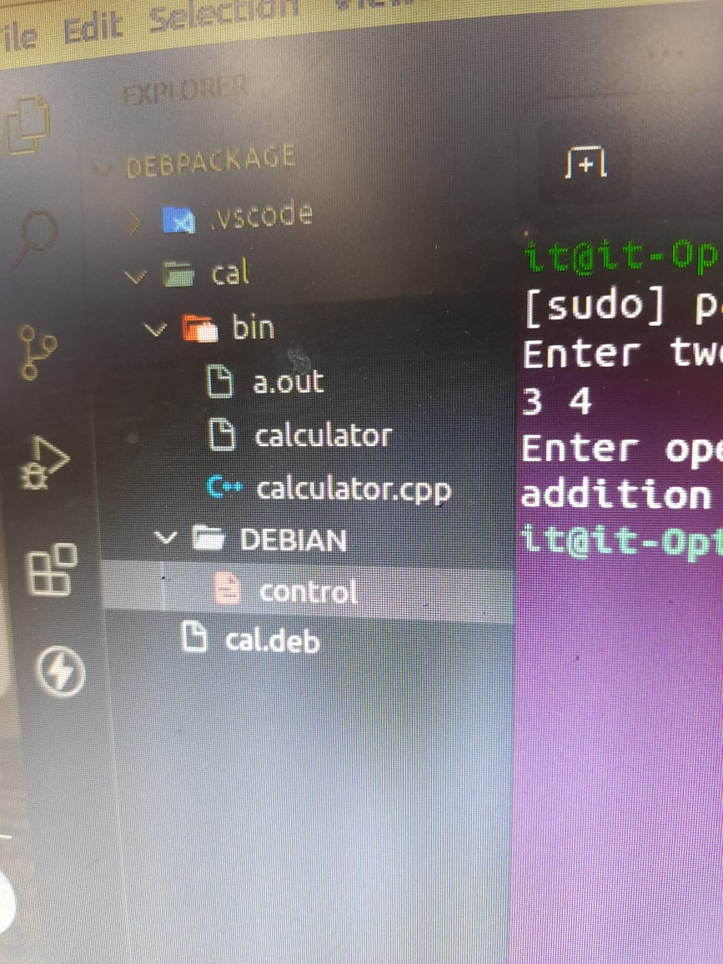

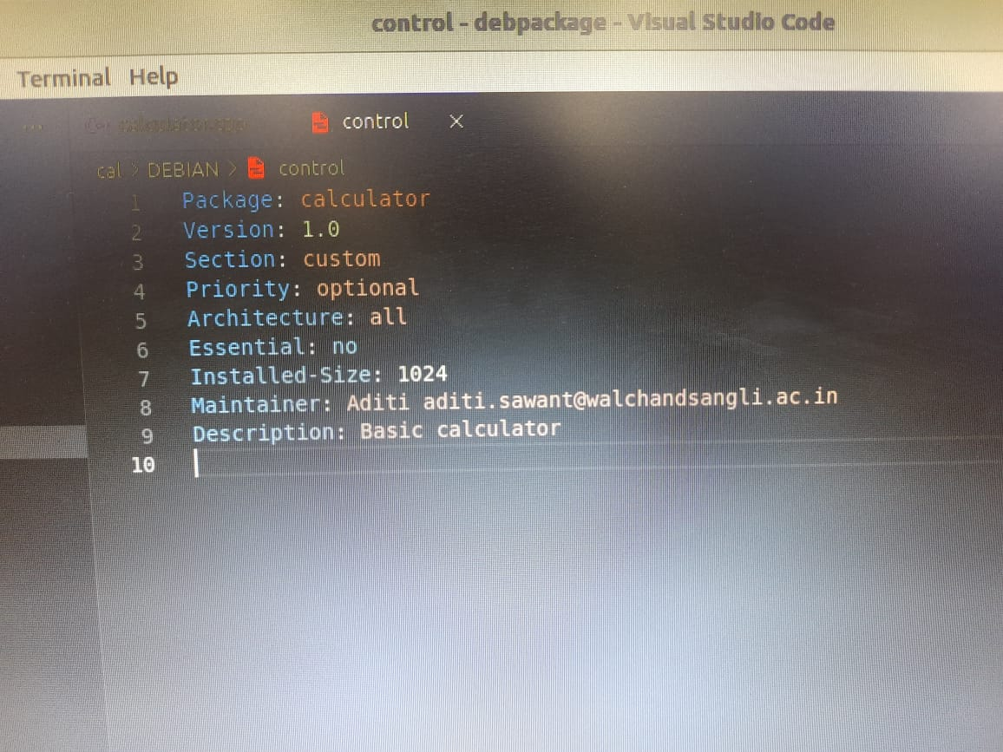

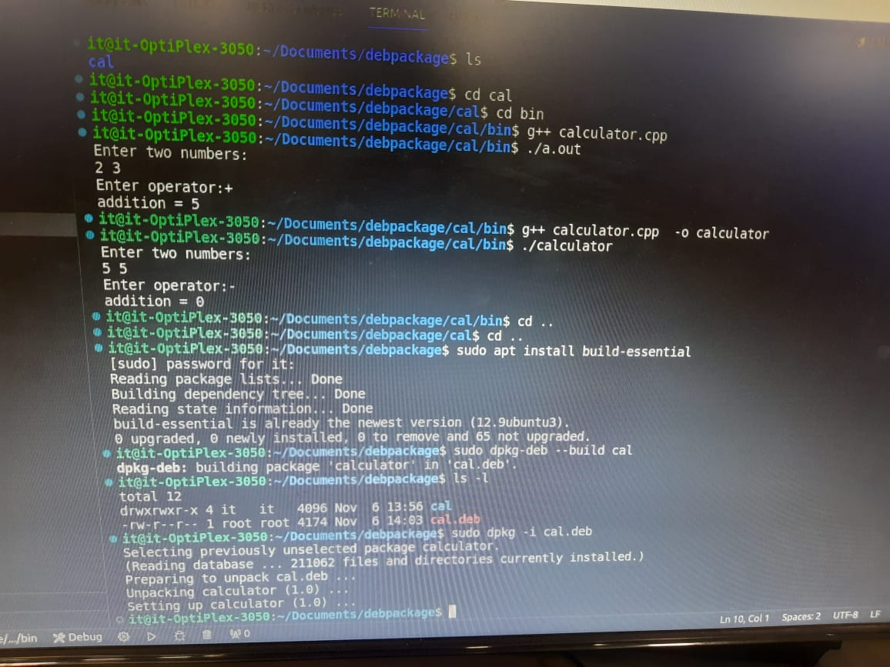

**Creating a Debian (DEB) package involves several steps, including organizing the package structure, creating necessary files, and using tools like dpkg to build and install the package. Below is a simple example to demonstrate how you can create a DEB package for a Python script that performs string addition.**

**Assuming you have the following Python script named string_addition.py:**

**python**

**Copy code**

**# string_addition.py**

**def add_strings(str1, str2):**

**return str1 + str2**

**if __name__ == "__main__":**

**print(add_strings("Hello", " World"))**

**Now, let's create a DEB package for this script:**

**1. Organize Package Structure:**

**Create a directory structure for your package:**

**plaintext**

**Copy code**

**my_string_addition/**

**|-- DEBIAN/**

**| `-- control**

**|-- usr/**

**| `-- bin/**

**| `-- string_addition**

**2. Create Control File:**

**Inside the DEBIAN directory, create a control file with package information:**

**plaintext**

**Copy code**

**Package: my-string-addition**

**Version: 1.0**

**Architecture: all**

**Maintainer: Your Name <your.email@example.com>**

**Description: Python script for string addition**

**3. Create Installation Script:**

**Optionally, you can include pre/post installation or removal scripts. For simplicity, we won't use them in this example.**

**4. Copy Python Script:**

**Copy your Python script into the usr/bin directory:**

**bash**

**Copy code**

**mkdir -p my_string_addition/usr/bin**

**cp string_addition.py my_string_addition/usr/bin/string_addition**

**5. Set Permissions:**

**Make the Python script executable:**

**bash**

**Copy code**

**chmod +x my_string_addition/usr/bin/string_addition**

**6. Build the DEB Package:**

**Navigate to the parent directory of your package and use dpkg-deb to build the DEB package:**

**bash**

**Copy code**

**dpkg-deb --build my_string_addition**

**This will create a DEB package named my-string-addition_1.0_all.deb.**

**7. Install the Package:**

**Install the DEB package using dpkg:**

**bash**

**Copy code**

**sudo dpkg -i my-string-addition_1.0_all.deb**

**8. Run the Python Script:**

**Now, you can run the Python script from the command line:**

**bash**

**Copy code**

**string_addition**

**9. Uninstall the Package:**

1. **SONAR**

[**https://www.digitalocean.com/community/tutorials/how-to-ensure-code-quality-with-sonarqube-on-ubuntu-18-04**](https://www.digitalocean.com/community/tutorials/how-to-ensure-code-quality-with-sonarqube-on-ubuntu-18-04)

1. **DRUPAL**

[**https://www.rosehosting.com/blog/how-to-install-drupal-on-ubuntu-22-04/**](https://www.rosehosting.com/blog/how-to-install-drupal-on-ubuntu-22-04/)

1. **NFS**

[**https://ubuntu.com/server/docs/service-nfs**](https://ubuntu.com/server/docs/service-nfs)

1. **MANTIS**

[**https://computingforgeeks.com/install-and-configure-mantis-bug-tracker-on-ubuntu/**](https://computingforgeeks.com/install-and-configure-mantis-bug-tracker-on-ubuntu/)

1. **Wordpress**

[**https://www.digitalocean.com/community/tutorials/how-to-install-wordpress-on-ubuntu-22-04-with-a-lamp-stack**](https://www.digitalocean.com/community/tutorials/how-to-install-wordpress-on-ubuntu-22-04-with-a-lamp-stack)

**sudo systemctl restart apache2**

**sudo apachectl configtest**

1. **FTP**

[**https://ubuntu.com/server/docs/service-ftp**](https://ubuntu.com/server/docs/service-ftp)

1. **Docker installation**

[**https://docs.docker.com/engine/install/ubuntu/#install-from-a-package**](https://docs.docker.com/engine/install/ubuntu/#install-from-a-package)

1. **Node Installation**

[**https://tecadmin.net/how-to-install-nvm-on-ubuntu-20-04/**](https://tecadmin.net/how-to-install-nvm-on-ubuntu-20-04/)

1. **MySQL installation**

[**https://www.digitalocean.com/community/tutorials/how-to-install-mysql-on-ubuntu-20-04**](https://www.digitalocean.com/community/tutorials/how-to-install-mysql-on-ubuntu-20-04)